**El pretérito v. El imperfecto**

|  |  |
| --- | --- |
| PRETÉRITOC:\Users\kulza\AppData\Local\Microsoft\Windows\Temporary Internet Files\Content.IE5\M8LN5XAF\MC900391200[1].wmf | http://judykerrblog.files.wordpress.com/2010/09/long-winding-road-disappearing-into-the-distance.jpg IMPERFECTO |
| ENFOQUE: _______________________________________  1. ______________________________________________  ________________________________________________  2. ______________________________________________  ________________________________________________  3. ______________________________________________  ________________________________________________  4. ______________________________________________  ________________________________________________ | ENFOQUE: _______________________________________  1. ______________________________________________  ________________________________________________  2. ______________________________________________  ________________________________________________  3. ______________________________________________  ________________________________________________  4. ______________________________________________  ________________________________________________ |

Preguntas para ayudarte con tu decisión

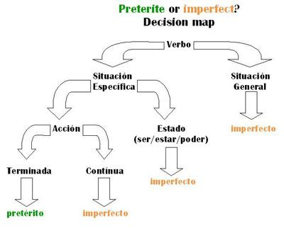¿Lo siento o es una emoción?

**Imperfecto**

¿Es un pensamiento o ejercicio mental?

**Imperfecto**

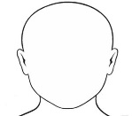

**LA pregunta: ______________________________________________________________________________**

Verbos que cambian de definición en el pretérito

**IR**

*Fui* a la sala de emergencia ayer.

*Iba* mucho a la sala de emergencia cuando era niña.

*Iba* al dentista cuando vi a Juan.

*Iba* a jugar pero se me rompió la pierna y no puedo andar.

1.________________________________________

2. ________________________________________

3. ________________________________________

4. ________________________________________

5. ________________________________________

6. ________________________________________

**Haber**

Hubo un accidente. Había muchas personas.