¡Bienvenidos a Español 3 con Profesora Kulz!
Let’s start with some FAQs
What can I expect from Spanish this year?
Most students are pretty nervous to start Spanish 3. Hopefully you’re more excited than nervous, but just in case, here is a quick overview. In Spanish 3 we continue to learn new and more complex vocabulary, and we review all the grammar concepts you did in Spanish 1 and 2 in order to aim at perfecting those concepts. This does not mean I expect perfection – it means that I expect a concerted effort to improve your Spanish. We will also do some reading, write short essays, play games, talk (a lot), collaborate on projects, act, listen to music and explore some cultural aspects of the language.

So, what will be expected of me?
I expect each and every one of my Spanish 3 students to speak only in Spanish during class - all period, every day. English is not to be spoken in class and this rule is strictly enforced. Again, this does not mean that I require perfect Spanish. I fully expect you to make thousands of mistakes and have moments when you don’t know what to say. I want you to try, to act it out, to use circumlocution, to draw me a picture … basically anything to communicate as much as you can in Spanish. I also expect that all students participate in all activities, collaborate, give their best effort and are kind, helpful and respectful of myself and their classmates. I also hope that my students can relax, allow themselves to be wrong, take ownership of their learning, have fun in class and show up with a positive attitude.

What happens if I am COMPLETELY lost???
Please come see me after school! I will help you in English if you need that extra support – but only after school (keeping in Spanish in the short amount of time we have in class is super important to all student’s acquisition of the language). There are also LOTS of resources at Skyline and online if you need help. Ask me or check the website if you need help finding extra support.
So I can use Google Translate then?!
Can I really use my phone/tablet?
What do I need for class?

All use of online translators is considered a violation of the Skyline High School Academic Honesty Code and will result in loss of credit. Please use dictionaries in order to find the correct word or phrase to convey your message.
Yes! In general, I encourage the use of internet-connected devices in my classroom! We use them frequently. All students are expected to use their devices responsibly and according to the ISD Personal Device Policy. Your phone/tablet/etc. should be used only for class activities and be put away during assessments or when otherwise directed.
- pencils
- colored pens
- whiteboard marker*
- old sock*
- paper
- organizer (binder, etc.)
- internet connected device*
*not required but highly encouraged
What do I need to do if I miss class?
Whether you miss class because you’re sick have a game, etc. you will need to check my website. All activities done in class, any available worksheets and tasks that need to be completed for the next day will be located on the En Clase 3 tab. The Calendario 3 tab will have all the upcoming due dates as well. If you have any questions, please ask me – but please check the website first. You have one week from the date of your absence to make up any missed work. Also, if you have a prearranged absence, please check with me prior to missing class to make sure there is nothing due upon your return.
How do grades work?
GRADES
Now on to the BIG question …
How do I get an A?
AKA How do grades work?

Please note that semester grades are earned over the entire semester. If you are concerned about your grade, please come see me as soon as possible if you would like me to either help you with a plan of action or extra support. Once we are more than half way through a semester, it becomes increasingly difficult mathematically for your grade to change.
Quizzes (20%)
Quizzes are a measure of a student’s progress in the unit and should reflect any further practice an individual student may need on any given concept in order to achieve mastery and better prepare for tests.

Final (10%)
There is a cumulative final exam at the end of each semester.

Formal & Informal Speaking (30%)
This includes in-class speaking activities, formal presentations, group dialogues, etc. These assignments will be announced in advance along with instructions and expectations. Each month you will also receive a grade that reflects your daily use of Spanish in class. This grade will be tracked using ClassDojo and will be based on quantity and quality of your spoken contributions in class.

Tests/Compositions (40%)
Tests are considered to be unit assessments and often cover whole chapters. They are used to evaluate mastery of unit concepts. Compositions are written works often in the form of in-class essays or written projects.

Any tips on how to get an A / be successful in Spanish?

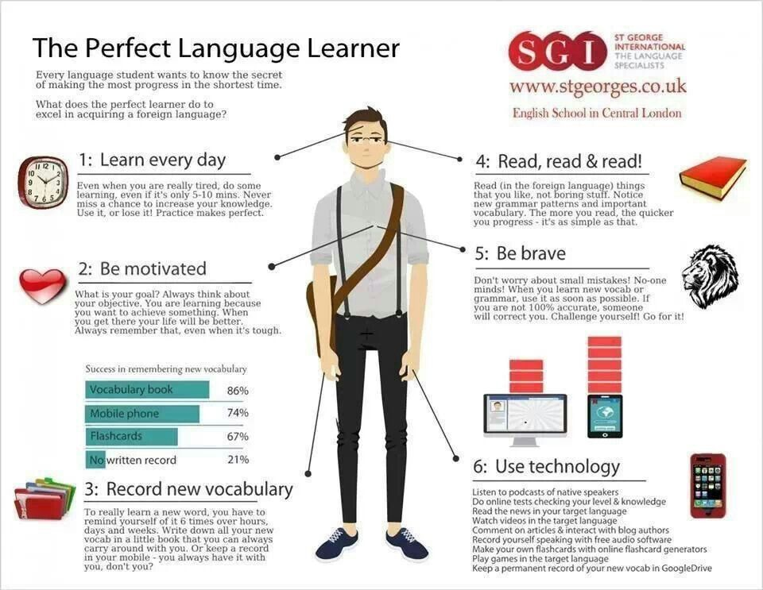
Goals for Spanish 3

I would like for ALL of my students to be successful this year in Spanish 3. Success looks different for everyone, but no matter what you are looking to achieve, setting goals is a huge part of being successful. So that is what we are going to do.

My goals for this year
- Help each one of my students to be able to express themselves exclusively in Spanish in all situations and with all people.
- Create safe, warm and fun environment in which each one of my students can learn and enjoy Spanish.
- Inspire in each one of my students interest, curiosity and/or passion for the Spanish language and cultures of the countries in which Spanish is spoken.

Your goals for this year
(Great time to think about ACTFL levels, “can do” statements, and what interests you. Your goal may NOT be about any grade.)
1. _________________________________________________________________________________________________
___________________________________________________________________________________________________
2. _________________________________________________________________________________________________
___________________________________________________________________________________________________
3. _________________________________________________________________________________________________
___________________________________________________________________________________________________

Your supervising adult’s goals for this year
(What would you like to see your student achieve in Spanish this year?)
1. _________________________________________________________________________________________________
___________________________________________________________________________________________________
2. _________________________________________________________________________________________________
___________________________________________________________________________________________________
3. _________________________________________________________________________________________________
___________________________________________________________________________________________________

Once you and your supervising adult have looked over the syllabus and set some goals together, please sign below and return only this sheet to Profesora Kulz. Please note that by signing this document you are stating that you understand all rules and policies and are agreeing to abide by all outlined expectations. You are also committing to striving to achieve the goals that you have outlined. Please make sure you are clear on all subject matter that is addressed in this document before signing.

__________________________________________________ __________________________________________________
Supervising adult’s signature and printed name Spanish 3 student’s signature and printed name

